**Background Paper (BP) on the ‘Policy lessons of country experiences with health and wellbeing (SDG3) in the wake of COVID-19’**

Yesim Tozan, PhD

School of Global Public Health, New York University, New York, NY 10003, USA

NYU Research Team: Kiera Bloch, Ariadna Capasso, Tyler Y. Headley, Sooyoung Kim

(by alphabetical order)

**Notes on the extended outline**

*We include a draft of the Viet Nam case study to illustrate the general framework that the eventual case studies on Cuba, Oman, Nigeria, Rwanda, and Peru will follow. Upon completion of the country case studies, we will finish the background paper’s comparative analysis and conclusions.*

**Abstract**

The COVID-19 pandemic has had profound effects on healthcare and other societal systems, as well as the global economy, and has disproportionately affected the disadvantaged groups, particularly people living in poverty and subjected to marginalization, worldwide. Although the national strategies for COVID-19 response are similar in nature, the timeliness, scale, and assertiveness of the response have varied considerably across countries. In this background paper, we attempt to answer three questions: How have different countries, particularly those that are resource-constrained, responded to the COVID-19 pandemic? What have been the main similarities and differences in policies and approaches that countries have taken to tackle this novel public health threat? And what key policy lessons can be drawn from these countries’ experiences for future public health crises? To be able to draw conclusions from the various COVID-19 response strategies and approaches taken by governments to mitigate the multi-faceted impacts of the pandemic, we compiled country case studies on Cuba, Nigeria, Oman, Rwanda, Peru, and Viet Nam. These six countries were selected on the basis of their varying levels of national progress towards universal health coverage over the past decade, their differing levels of pandemic preparedness and response capacity, and their overall level of economic development. Given that the COVID-19 pandemic is still ongoing, we relied on national and other official policy documents on COVID-19 response from the start of this public health crisis in January 2020 to date and academic literature, and employed a qualitative case study methodology. Where possible, we used quantitative data from international and national sources to provide context or support our main arguments and findings. We hope that the findings of this analysis will help strengthen overall resilience in all nations and inform the development of synergistic systems for a sustainable global recovery from COVID-19 and future public health crises.

**Introduction**

*The global ramifications of the COVID-19 pandemic*

* Since late 2019, when the COVID pandemic was first discovered in China, the number of cases worldwide is roughly XX million. [include data on the scale of the pandemic when finalizing the background paper].

* Understanding countries’ responses to the COVID-19 pandemic is important for two primary reasons: first, it allows policymakers to better understand the impact of different national strategies and approaches used to implement these strategies through their health systems. Second, an analysis of national strategies to the pandemic allows researchers to better gauge the nature of the global response, and facilitate more accurate and timely research on governments’ responses to COVID-19.
* While some COVID-19 response measures, like international border restrictions, school closures, national lockdowns, and restrictions on non-essential businesses have been broadly adopted by countries as part of their national strategies, there has been stark variation in the implementation of other response measures such as domestic travel restrictions, the creation of new task forces, or the restriction of non-essential government services [1]. Such variation in the types of response measures exists not only between countries, but even within countries—for instance, many states in the United States of America have adopted markedly different response measures to combat the pandemic [2, 3]. There has also been substantial variation in the timing and sequence of implementation, particularly in the initial stages of the pandemic; while some countries were slow to ramp up their response to COVID-19 until they started experiencing COVID-19-related deaths (e.g., the United Kingdom, Colombia), other countries mounted an aggressive and comprehensive response even before seeing any marked increases in cases (e.g., Viet Nam, Taiwan, South Korea). In these regards, the emerging lessons highlight the paramount importance of political readiness and ability to mount coordinated action from central to local levels, particularly across the health sector, and the level of trust and government legitimacy among the public, as well as the significance of past experience with pandemics and the resulting level of public health emergency preparedness. Of note, countries initially appeared to have observed their neighbors’ responses and acted in concert before diverging policy-wise in later months, which in part explains why various regions had initially similar levels of COVID-19 case counts [4]. Further, some countries have shown high degree of adaptive capabilities in their response (e.g., Viet Nam and Germany) where both central and local governments continuously amended or created, and deployed new policies in harmony to respond to the evolving pandemic in a timely manner, while also prioritizing corrective actions when necessary in light of the accumulating experience and scientific knowledge base related to COVID-19.
* It is readily apparent that COVID-19 has had differential impacts across countries as well as across populations within countries, disproportionately affecting those that are poor, minority, or vulnerable [5]. The difficulty of any analysis, including this one, is objectively parsing out how much of the differential impact of the pandemic is due to countries’ pandemic response as compared to pre-existing conditions within countries, such as a country’s pandemic preparedness and response capacity, disease surveillance and health system capacity and infrastructure. Other facets of disease spread, like the frequency of travel to and from countries with high levels of disease prevalence, may also account for some of the variation in the impact of COVID-19.

*Contributions of this background paper*

* First, the evidence base on governmental response to the COVID-19 pandemic has largely fallen into two categories: broad, global datasets that compile surface-level data on countries’ policies; and in-depth qualitative research studies that have generally, though not always, focused on pandemic response in high-income country settings. We aim to contribute to the academic literature by observing how different countries, with a particular focus on those in low- and middle-income settings, have responded to the COVID-19 pandemic. Such countries are more likely to face higher disease burden and social and economic pressure due to COVID-19 because of their weaker health system capacity and infrastructure and heightened demand for health care [6].
* Second, this background paper aims to not just describe what each of the chosen countries has done but specifically elucidate the similarities and differences in the policies and approaches countries have used to confront the challenges posed by the COVID-19 pandemic.
* Third, we aim to proffer lessons learned based on a novel analysis of countries’ policies and approaches—both successful and unsuccessful—to the COVID-19 pandemic. In drawing these conclusions, we aim to fulfil two key objectives: to provide information that could inform the national strategies and approaches to combatting the pandemic now and, also in its aftermath, and to draw the lessons of this pandemic that could inform countries’ responses to similar future public health emergencies.

*Methodology*

* Until the COVID-19 pandemic has run its course, there are intrinsic difficulties in assessing the validity of countries’ self-reported data or third-party data on case numbers or fatalities. There are additional challenges in that there have been limited differences in national strategies and response measures implemented across and within countries, particularly during the initial phase of the pandemic (March-May 2020) [4, 7]. Although there have been clear differences in the level of implementation and level of adherence to those policies, ascertaining these facets of implementation is difficult while the pandemic is still ongoing. We thus attempt to draw conclusions by primarily using qualitative data and information from national and other official policy documents on COVID-19 response and academic literature to compare countries’ response strategies and the resulting COVID-19 impacts. However, we do present quantitative data to buttress our arguments and findings when possible and when we have confidence in the data as presented.
* Determining which countries to include in our study was difficult for two reasons: first, the pandemic is still ongoing, so some countries that were previously lauded for their response may incur a large burden of disease after publication; and second, countries have experienced very different rates of COVID-19 cases even when compared to countries which are located in the same region or income group, or have made similar progress towards UHC (see Figure 1). We therefore attempted to select countries, especially those in resource-constrained settings, which took different policy approaches to the pandemic, and qualitatively inferred what effect those policies had on COVID-19 outcomes to date.

Figure 1. XXX

*Brief summary of findings (second draft)*

* We find that a government’s level of pandemic preparedness, the speed with which it responded to the spread of COVID-19, and the comprehensiveness of its pandemic response measures impacted a country’s ability to cope with the pandemic. Meanwhile, although there is only moderate evidence that a government’s level of UHC impacted the effectiveness of the government’s ability to address the COVID-19 pandemic, there is other evidence to suggest that UHC may impact a country’s ability to recover quickly after the pandemic loosens its grip on the global community.
* These lessons are especially important for much of the developing world which, as of writing, has been disproportionately less affected by the pandemic; these countries are therefore more susceptible to the many variants of the COVID-19 virus. Many developing countries already face an uphill battle due to constrained economic resources and health systems which have already become overwhelmed in anticipation of the virus. By incorporating the best practices highlighted in this study, developing countries will hopefully experience a flattened learning curve when mitigating new waves of the virus.
* Though COVID-19 will have significant health and economic ramifications for countries which experience a large burden of disease, we note that as of writing, the internal stability of all the countries profiled in this study has not been significantly impacted. We additionally highlight the opportunities that have arisen from the pandemic, especially the opportunities for increased international collaboration on health system strengthening, increased investment in and progress towards UHC adoption in resource-constrained settings, and strengthened disease surveillance efforts across regions.
* Most of the countries profiled in this study were focused on disease prevention and mitigation efforts due to the novelty and immediate impacts of COVID-19. As the pandemic continues its course and fully available vaccines remain years away, the countries profiled herein will likely begin engineering and implementing new strategies to co-exist with COVID-19. Co-existence presents new challenges both to countries’ health systems and countries’ progress towards SDG3 targets. Countries will be challenged with finding the right balance between economic investment in COVID-19 prevention versus other goals which require financing, as well as between stringency and ease-of-movement (Figure 2 highlights the extremely varied policy approaches currently employed by countries). Continued investments in health system resilience may prove the most effective, as they allow countries to concurrently make progress against COVID-19 and the SDG3 targets.

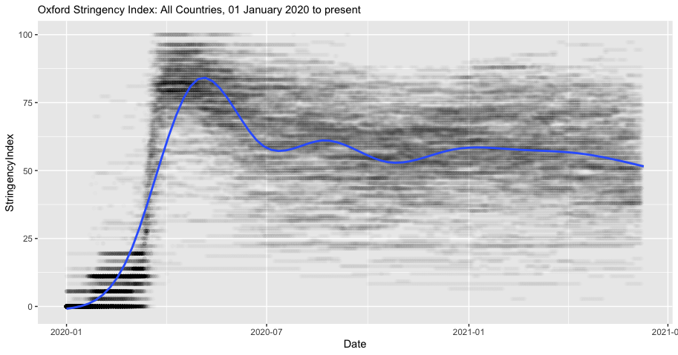  
Figure 2. Oxford Stringency Index with average trendline

(Figure and Analysis by Authors)

**Case studies**

**Viet Nam: Pandemic Preparedness and Quick Government Reaction Saves Lives**

*Introduction*

Viet Nam, a lower-middle income country of 97 million people located in the Asia Pacific region, has been a notable success story for its ability to control the COVID-19 pandemic during the first 12 months of the worldwide outbreak. Yet its success was not assured: Viet Nam shares a 1,300 km land border with China, which accounts for a large proportion of travelers to Viet Nam; the start of the outbreak coincided with the Vietnamese Lunar New Year, when much of the population travels; and two-thirds of the detected cases were asymptomatic [8]. Despite these factors, as of March 1, 2021, Viet Nam had a total of just over 2,000 cases, which corresponds to roughly 3 cases per million people (X). Nonetheless, the country continues to face imminent threats from imported cases and the emergence of new SARS-CoV-2 variants, particularly in the light of the slow roll-out of COVID-19 vaccines. As a matter of fact, Viet Nam is currently experiencing a third wave of community transmission, setting in motion a tightening of controls and new testing campaigns in several regions of the country. This reveals the delicate nature of hard-won containment gains and the urgent need for achieving widespread vaccine coverage as key to a sustainable exit from the pandemic.

*Overview of the health system and progress towards UHC*

Viet Nam has a mixed public-private system in which the public system is organized by the Ministry of Health (MoH) in a two-track system focusing on prevention and clinical acute care [9]. The two tracks also span multiple levels ranging from central (Level I), which covers the entire country, to commune (Level IV), which covers fewer than 10,000 people [10]. While the government fully subsidizes premiums for special categories of citizens, including the poor, children under six years of age, and war veterans, the predominant payment method is fee-for-service, wherein fees differ by province and are set jointly by the MoH, the social health insurance agency, and the Ministry of Finance [9].

While Viet Nam has made significant progress towards achieving UHC, it has not yet achieved full coverage of its population. Social health insurance in Viet Nam began as early as 1992, and Viet Nam’s 2008 Law of Health Insurance called for universal coverage by 2014 [9]. However, Viet Nam’s march towards UHC is still incomplete. Although since 2016 Viet Nam had not earmarked a budgetary commitment to UHC, a Lancet study found that UHC was still a high priority budget item; the same study concluded that while Viet Nam had initial programs and systems of implementation for UHC in progress, there was still a need for further systems development and capacity building to reach the population not yet covered [11]. As of 2019, IHME estimated that Viet Nam had achieved 60% effective UHC coverage, an increase of 3-percentage points from 2010 [12].

Viet Nam, along with many countries in Southeast Asia, has been going through rapid development and ever-changing population dynamics. While their economy is also steadily improving, the pace has not yet caught up with its population growth rate, leaving high proportion of households, mostly concentrated in rural areas, in poverty. In rural areas, including the Northwest and Central Highland regions where remote mountainous communities are predominant and the fertility remains high, maternal and child care quality is suboptimal and the maternal and neonatal mortality rate is almost twice as high as the national average.[ref] Fast changing population dynamics, including high birth rate as well as the rapidly ageing population, creates complicated dynamics of the infectious disease patterns and the burdens of both communicable and non-communicable diseases. Uncontrolled immigration from neighboring countries adds to the existing issues the healthcare system must address.[ref]

Despite all abovementioned challenges, Viet Nam achieved some great progress towards SDG-3 in the past decade, shedding hopes to the future of their healthcare system. The country publishes annual report on their progress towards SDG goals jointly with the UN agencies.[ref] According to their most recent report published in 2018, between 2000 and 2015, their effort has been focused on reducing the burden of communicable diseases, including the HIV/AIDS and Tuberculosis, whose incidence and deaths have been reduced significantly during the period. They also succeeded in reducing the traffic accidents and road injuries.[ref] As of the time the report is being drafted, UN and the interagency partners are implementing 77 key activities across various locations in Viet Nam with the common aim to achieve SDG targets.[ref]

It is worth noting that, in the past decade, they invested vigorous effort in reinforcing policy and law related to public health and social welfare. One comparative study compared Viet Nam and China’s public health law coverage and concluded that Viet Nam has an overall high coverage of public health laws across various topics.[ref] The SDG progress report also highlighted the recent rollouts of the law on social insurance, medical examinations and treatments, as well as the National Strategy to Protect, Care and Improve Public Health.[ref] While the rural-urban disparities in maternal and child health indicators currently remain as a key issue, Viet Nam has been rolling out the strong neonatal care guidelines across the country, including the mountainous rural communities.[ref] Overall, their focus on law and policy reinforcement is considered the right approach in building the strong backbone of the future health system with strong resilience and long-term sustainability.

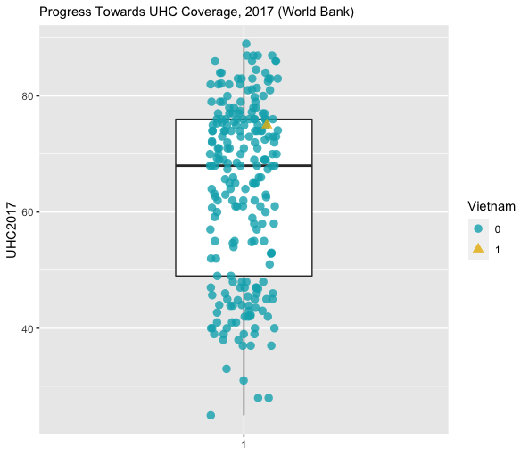

Viet Nam faces three primary health systems related challenges that complicated its response to COVID-19. First, the country generally faces overcrowding in hospitals; according to a recent interview conducted right before COVID, Viet Nam had about 24.5 beds per 10,000 population [9]. Even prior to COVID-19, this led to bed occupancy rates reaching 120%-160%, especially in the central hospitals of some large cities [10]. Second, there is an urban-rural health divide, wherein people living in rural settings often have pre-existing comorbidities and limited access to health services [13]. Third, there is also a shortage of physicians; Viet Nam reported roughly 8 physicians per 10,000 people in 2015 [10]. These factors raised questions of healthcare capacity during COVID-19, and also highlight why Viet Nam focused so much of its efforts during the pandemic on preventing the spread of disease. Although Viet Nam’s progress towards UHC may not account for its success in controlling the pandemic during the first year of the pandemic—instead, Viet Nam’s high level of pandemic preparedness and rapid and swift governmental response seem to have played a larger role—it may help the country recover faster in the aftermath of the pandemic. Moreover, given the country’s current investment in reinforcing the law and policy to build resilient health system, coupled with its experience with the COVID-19, Viet Nam may be able to respond to the next pandemic more effectively. The key for the future health system’s success, however, might rely on how the system come up with the solution to embrace the ever-growing immigrant population in the context of expanding their UHC.

*Pandemic preparedness and response capacity*

Over the last few decades, Viet Nam accumulated substantial experience in controlling infectious diseases, including malaria, HIV/AIDS, tuberculosis, and parasitic diseases; as a result of disease surveillance efforts, these diseases have led to markedly fewer premature deaths in the population during this period [cite IHME GBD]. However, Viet Nam’s most pertinent experience was dealing with emerging infectious disease epidemics, notably SARS-CoV-1 in 2003 (Viet Nam was the first country to successfully control Severe Acute Respiratory Syndrome, SARS), Swine Flu (H1N1), and Avian influenza (H5N1) in 2004 [9]. Viet Nam’s fairly recent fight with these epidemics has not only led to institutional-level preparedness and planning capacity for pandemics [14], but also social memory, which may have led to strong public support of regulations and guidance related to COVID-19 and a high degree of adherence to personal and community preventive measures recommended by the government [15].

The WHO’s 2016 International Health Regulations (IHR) Joint External Evaluation (JEE) found that Viet Nam had a high level of capacity in the technical areas of IHR coordination, communication and advocacy, zoonotic diseases, real-time surveillance, and immunization. This is mainly because Viet Nam has made a strategic decision to invest in its public health infrastructure in the aftermath of the SARS epidemic and developed a national public health emergency operations center and a national public health surveillance system. The national center along with four regional centers have since then run exercises and trainings to prepare key stakeholders in government for outbreaks, and have managed preparedness and response efforts for measles, Ebola, Middle East respiratory syndrome (MERS), and Zika. Hospitals are required to report notifiable diseases within 24 hours to a central database, ensuring that the Ministry of Health can monitor epidemiological events across the country. Much of Viet Nam’s response mechanisms is also a by-product of decades of engagement with global health organizations; for instance, the US Centers for Disease Control and Prevention has been working with Vietnam since 1998, providing input on disease screening, prevention, and laboratory capacity [8]. In 2018, an innovative event-based surveillance program, which empowers members of the public to report unusual public health events, was implemented in collaboration with this agency (x). This is not to say that all levels of government were equally prepared to respond to the COVID-19 pandemic; operational readiness among grassroots health providers was found to be only moderately effective [17]. Additionally, the IHR-JEE review previously noted that there was a need to strengthen multisectoral collaboration, coordination and information sharing, and sustainable investment in health security [16].

*Response to COVID-19*

In mid-January, well in advance of the first COVID-19 case in the country, the government of Viet Nam issued first the national response plan and technical treatment and care guidelines for COVID-19, and then the national surveillance guidelines (X). This early action resulted in the successful identification of the first two cases on 23 January 2020 and containment of the first community transmission chain in the country. Immediately after, Viet Nam suspended all flights from and to Wuhan, China, and established a national steering committee to prevent and control COVID-19. Contact tracing and quarantine measures (self-quarantine at home and quarantine at non-medical and medical facilities (X)) were immediately put into place. When a case was confirmed, the authorities would trace to the fourth contact level from the confirmed case [18]. Further, social distancing measures, face mask use, and in-country travel restrictions were enacted and enforced (X) [19]. Further, communication between the government units and between the government and the public was prioritized from the start of the pandemic, with regular updates on outbreak status and government actions. To this end, with the encouragement of the government, a number of mobile applications were rapidly developed and provided free of charge to citizens (X). Measures were also imposed to prevent hoarding and price-gouging for basic personal protective equipment (PPE) [8]. Further, in February, Viet Nam closed the shared border with China and suspended all flights between the two countries. During the first two months into the pandemic, only 16 cases were reported. From 26 February to 5 March 2020, there were no new confirmed cases of COVID-19.

In early March 2020, cases started to increase in number due to imported COVID-19 cases from Europe and the US [18], and community transmission was indicated due to the identification of cases with no travel history and no apparent contact with COVID-19 patients. As a result, the government put into place a multi-jurisdictional cooperation mechanism between local authorities and health stations to conduct sensitive and broad contact tracing on all passengers in planes that had reported cases of COVID-19. Contact tracing was implemented as a joint effort between the Ministry of Health, the Ministry of Technology and Science, the Ministry of Public Security, the local CDC, and local authorities. Mandatory COVID testing and a 14-day quarantine at a government-run isolation center were required for all international passengers. There were, though, concerns that the implementation of a 14-day quarantine for close contacts of international travelers would lead to a shortage of quarantine space [18]. During this period, all Vietnam residents were requested to wear a face mask in public places; gatherings of 10 or more people were prohibited; schools were closed; and intracity/intercity movement restrictions were enacted [19]. On March 28, Vietnam enacted a blanket travel ban for all international flights despite WHO’s advice against travel bans at the time [19]. On 31 March, with the total number of reported cases rising above 200, the Prime Minister called for urgent and stricter measures to halt community transmission, including a 15-day nationwide lockdown, where people were allowed to leave their houses for only essential activities, such as seeking medical care or buying food (X). This included shutting down non-essential businesses and public transport, allowing only essential travel between cities and provinces, and prohibiting gatherings of more than 2 people in public places. The lockdown was extended for another 15 days in high-risk cities and was in effect until the end of April. In parallel, mass testing for COVID-19 continued, and testing was streamlined with an innovative sampling method where nasal and throat swabs from 2-7 individuals were placed in a single tube at collection. An online system was launched to provide support to all health facilities located in remote areas on medical counseling, consultation, imaging diagnosis, pathology to eliminate geographic and social barriers and enhance diagnosis and treatment capacity for COVID-19 (X). All these measures were applied with increasing stringency until this second wave of community transmission was successfully brought under control in early June. Testing, treatment and quarantine (food and accommodation) costs were covered by the government (X). Thereafter, testing and contact-tracing continued, and quarantine measures were enforced vigilantly as new small-scale outbreaks were identified and contained during the rest of the year. As of 21 January 2021, Viet Nam reported 1,521 COVID-19 cases and experienced low mortality rates.

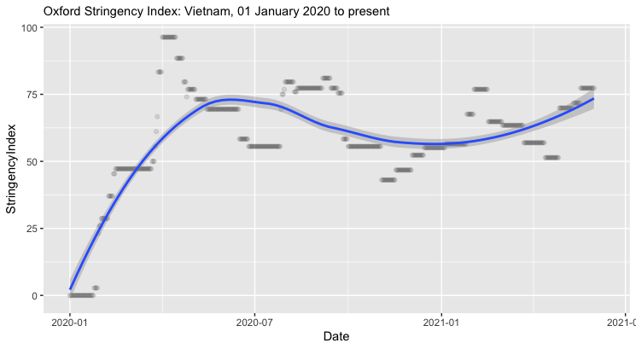

Figure XX. Oxford Stringency Index. Figure and Analysis by the authors.

The success of Viet Nam’s policy response in the first 12 months of the pandemic has been attributed to a variety of factors, including swift policy action of the government due to the nature of its political mechanisms and administrative systems facilitating rapid and effective coordination horizontally across central government units and vertically from central to local levels (X); the country’s high level of pandemic preparedness as a result of its experiences with past public health crises, long-running engagement with global health organizations and the resulting willingness to follow globally recommended protocols for pandemic response [19]; clear prioritization of public health above economic considerations thorough a “proactive and comprehensive” response by the healthcare system, combined with an energetic and creative public education campaign [22]; mass mobilization of government and civil society organizations in a “whole of society” approach to draw on knowledge and capacities from across multiple sectors and ministries [20][21]; fostering cooperative national sentiment and solidarity through timely and transparent communication on the outbreak-related developments by the government and the media which fostered trust and credibility of the government among the public (x); and the country’s adaptation capabilities whereby central and local governments has continually amended and created new policies and has rapidly adjusted and fine-tuned response measures based on scientific and epidemiologic data in response to new outbreaks in the country [8]. While these factors indicate due preparedness, it was the flexibility and capacity to respond rapidly and decisively on pertinent policy areas that helped the country to stay ahead of the pandemic’s progression during the first three waves.

*Conclusion*

Despite being a resource-constrained country, Viet Nam successfully contained the COVID-19 outbreaks during the first year of the pandemic while little was known about the virus. This is in contrast to other countries in Asia with similar levels of economic development, such as India, the Philippines and Indonesia. Viet Nam’s success in handling the COVID-19 pandemic was perhaps attributable more towards its recent experiences with epidemics and ensuing investments in its public health infrastructure, as well as its political and administrative systems that facilitate cooperation within the government units and between the government and the public. The same spirit of the command-and-control architecture of Viet Nam’s political and administrative systems, which facilitated effective coordination and management of activities for the COVID response horizontally and vertically, is also predicted to serve the post-pandemic economic recovery effort through fiscal stimulus and public investment [8, 23]. In the post-pandemic world, Viet Nam’s steady progress towards UHC may play a role in its economic and social recovery from COVID-19.

*Takeaways*

* Viet Nam, a lower-middle income country located in the Asia Pacific region, was highly successful at controlling COVID-19 during the first 12 months of the pandemic
* Viet Nam’s success is attributable to its previous experience combatting epidemics like SARS, high-level of pandemic preparedness, rapid and comprehensive action, and its adaptive capabilities in its COVID-19 response.
* While Viet Nam’s progress towards UHC may not have played a major role in Viet Nam’s successful COVID response, its UHC capacity may enable the country’s successful economic and social recovery from COVID-19

**Oman**

* *Introduction*
* *Overview of the health system and progress towards UHC*

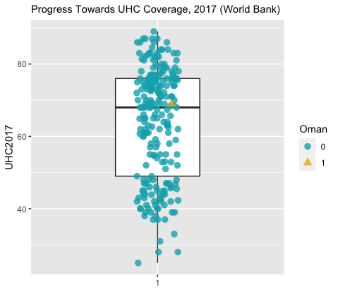

* *Pandemic preparedness*
* *Response to COVID-19*

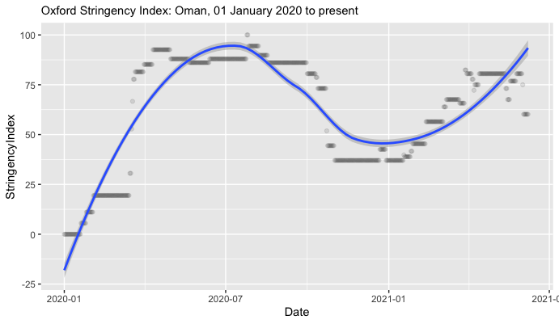

* *Conclusion*
* *Takeaways*

**Nigeria**

* *Introduction*
* *Overview of the health system and progress towards UHC*

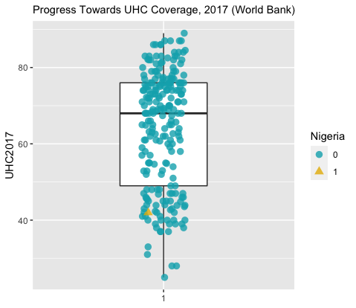

* *Pandemic preparedness*
* *Response to COVID-19*

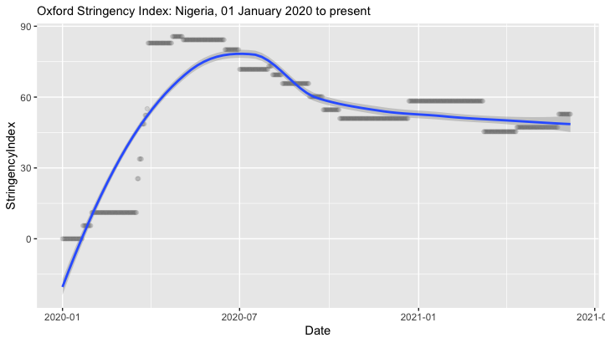

* *Conclusion*
* *Takeaways*

**Rwanda**

* *Introduction*
* *Overview of the health system and progress towards UHC*

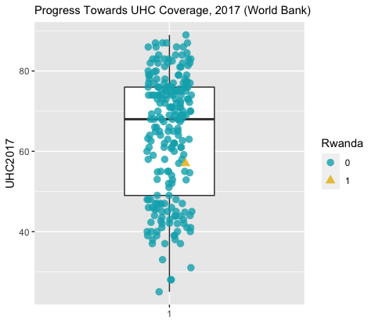

* *Pandemic preparedness*
* *Response to COVID-19*

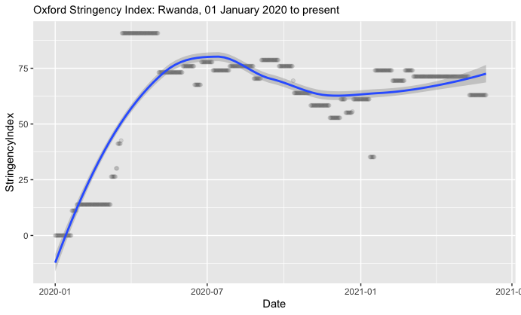

* *Conclusion*
* *Takeaways*

**Peru**

* *Introduction*
* *Overview of the health system and progress towards UHC*

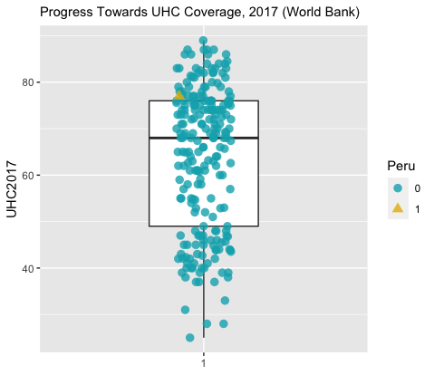

* *Pandemic preparedness*
* *Response to COVID-19*

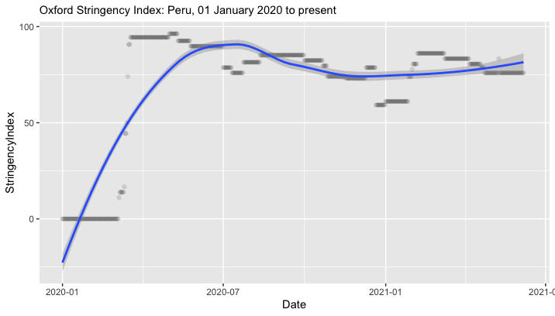

* *Conclusion*
* *Takeaways*

**Comparative analysis**

* Initial findings have identified that limiting gatherings to fewer than 10 people, closing high-exposure businesses, and closing schools and universities were more effective policies than stay-at-home orders [24]. We find that this makes sense in the context of our inquiry, specifically that the case studies indicate that governments’ abilities to both quickly initiate and then enforce these policies—or have societies that are amenable to adherence with these policies on their own volition—was integral to their ability to contain the COVID-19 pandemic.

*Pandemic responses in resource-constrained settings*

* Counterintuitively, the economic strength of a country can delay necessary government action to address the pandemic [25].

*Primary similarities and differences in policies and approaches across countries*

*What has been effective?*

* Fiscal expenditures on health, regional and local government capacity, and pressure on a health system can accelerate government responses [25].

*The role of UHC coverage*

*Key policy lessons*

**Conclusion**

* Impact of COVID-19 on health systems
* COVID-19 pandemic will speed up adoption of digital public service provision [26], possibly including other public service provisions including a transition to UHC.

**Works Cited**

1. Cheng, C., et al., *COVID-19 government response event dataset (CoronaNet v. 1.0).* Nature human behaviour, 2020. **4**(7): p. 756-768.

2. Hale, T., et al., *Variation in government responses to COVID-19.* Blavatnik school of government working paper, 2020. **31**: p. 2020-11.

3. Mintrom, M. and R. O’Connor, *The importance of policy narrative: effective government responses to Covid-19.* Policy Design and Practice, 2020. **3**(3): p. 205-227.

4. Hale, T., et al., *A global panel database of pandemic policies (Oxford COVID-19 Government Response Tracker).* Nature Human Behaviour, 2021. **5**(4): p. 529-538.

5. Kansiime, M.K., et al., *COVID-19 implications on household income and food security in Kenya and Uganda: Findings from a rapid assessment.* World development, 2021. **137**: p. 105199.

6. Walker, P., et al., *Report 12: The global impact of COVID-19 and strategies for mitigation and suppression.* 2020.

7. Goodman, M.P., S. Segal, and M. Sobel, *Assessing the G20 Virtual Summit.* Center for Strategic and International Studies, 2020. **27**.

8. Hartley, K., S. Bales, and A.S. Bali, *COVID-19 response in a unitary state: emerging lessons from Vietnam.* Policy Design and Practice, 2021. **4**(1): p. 152-168.

9. Cheng, T.-M., *Vietnam’s health care system emphasizes prevention and pursues universal coverage.* Health Affairs, 2014. **33**(11): p. 2057-2063.

10. Takashima, K., et al., *A review of Vietnam’s healthcare reform through the Direction of Healthcare Activities (DOHA).* Environmental health and preventive medicine, 2017. **22**(1): p. 1-7.

11. Reich, M.R., et al., *Moving towards universal health coverage: lessons from 11 country studies.* The Lancet, 2016. **387**(10020): p. 811-816.

12. Murray, C.J., et al., *Global burden of 87 risk factors in 204 countries and territories, 1990–2019: a systematic analysis for the Global Burden of Disease Study 2019.* The Lancet, 2020. **396**(10258): p. 1223-1249.

13. Tran, B.X., et al., *Health status and health service utilization in remote and mountainous areas in Vietnam.* Health and quality of life outcomes, 2016. **14**(1): p. 1-9.

14. Thu, H.L., *Vietnam: A Successful Battle Against the Virus.* Asia Unbound (New York: Council on Foreign Relations), 2020.

15. Hartley, K. and D.S. Jarvis, *Policymaking in a low-trust state: Legitimacy, state capacity, and responses to COVID-19 in Hong Kong.* Policy and Society, 2020. **39**(3): p. 403-423.

16. Organization, W.H., *Joint external evaluation of IHR core capacities of Viet Nam: mission report: 28 October-4 November 2016*. 2017, World Health Organization.

17. Tran, B.X., et al., *The operational readiness capacities of the grassroots health system in responses to epidemics: Implications for COVID-19 control in Vietnam.* Journal of global health, 2020. **10**(1).

18. Nguyen, T.H. and D.C. Vu, *Summary of the COVID-19 outbreak in Vietnam–Lessons and suggestions.* Travel medicine and infectious disease, 2020.

19. Quach, H.-L. and N.-A. Hoang, *COVID-19 in Vietnam: A lesson of pre-preparation.* Journal of Clinical Virology, 2020. **127**: p. 104379.

20. Black, G., *Vietnam may have the most effective response to Covid-19.* The Nation, 2020. **24**.

21. Dabla-Norris, E., A.-M. Gulde-Wolf, and F. Painchaud, *Vietnam's Success in Containing COVID-19 Offers Roadmap for Other Developing Countries.* IMF Country Focus, 2020.

22. Hoang, V.M., et al., *Describing the pattern of the COVID-19 epidemic in Vietnam.* Global health action, 2020. **13**(1): p. 1776526.

23. Morisset, J., *Vietnam: Potential Policies Responses to the COVID-19 Epidemic*. 2020, World Bank.

24. Brauner, J.M., et al., *Inferring the effectiveness of government interventions against COVID-19.* Science, 2021. **371**(6531).

25. González-Bustamante, B., *Evolution and early government responses to COVID-19 in South America.* World development, 2021. **137**: p. 105180.

26. Agostino, D., M. Arnaboldi, and M.D. Lema, *New development: COVID-19 as an accelerator of digital transformation in public service delivery.* Public Money & Management, 2021. **41**(1): p. 69-72.